**Describe the core message or hypothesis for your project**

Vaccinations have decreased the impact of Covid-19 outcomes

**Describe the questions you and your group found interesting and what motivated you to answer them**

1. What are the latest Covid-19 case numbers by country? (looking for current scenario)
2. What is the death ratio between countries? (we wanted to understand what impact Covid-19 has had on death worldwide)
3. What is the relationship between vaccination rate and death, ICU, and hospital admissions? (we wanted to investigate if data shows a decrease in these outcomes)
4. What impact does a country’s wealth have on vaccination rollout? (we wanted to understand the availability of the vaccines worldwide, is there a disadvantage for lower income countries)

**Summarize where and how you found the data you used to answer these questions**

We found a global Covid-19 dataset used by news media (ABC news) from ‘Our World in Data’ that contained covid data by date and country.

**Describe the data preparation and cleanup process (accompanied by your JN)**

Exclusions and why

**Describe the analysis process (accompanied by your JN)**

**Summarize your conclusions. This should include a numerical summary (ie what data did your analysis yield) as well as visualizations of that summary (plots of the final analysis data)**

Final dataset of….(rows/cols) for analysis. Descriptive info such as how many countries, what the date range included was, summary of charts/plots

**Discuss the implications of your findings. This is where you get to have an open-ended discussion about what your findings “mean”**

A country’s wealth is likely to have an impact on the availability of vaccinations.

Our analysis showed that only 2% of countries with a low GDP per capita have reached 25% vaccination rates compared with 42% of countries with a low to mid GDP per capita, 72% of countries with a mid to high GDP per capita, and 98% of countries with high GDP per capita.

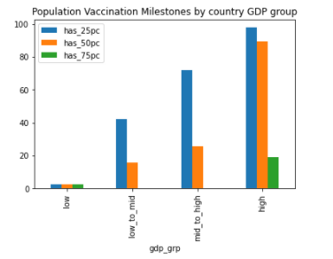

We also found that a country’s wealth had a likely impact on the speed of vaccination rollout. The median number of days it took a country to start their vaccination rollout from the start of the first cases of Covid-19 was higher for countries with a low GDP per capita. Our analysis showed that the median (IQR) days from first Covid-19 case to first vaccination was 399 (363, 455) for low GDP per capita countries, 387 (355,407) for the low to mid group, 351 (322,394) for the mid to high group and 333 (304,365) for the high group.

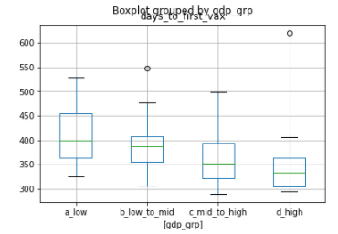

Our findings show that vaccination has a positive impact on outcomes worldwide and has reduced the number of deaths, ICU and hospital admissions.

Our findings suggest that globally there is a long way to go before a significant proportion of the world’s population is vaccinated.

Further action is needed to close the gap of vaccine availability between low and high income countries.

**Tell a good story. Find your narrative and use your analysis and visualization skills to highlight conflict and resolution in your data**